**Install the React App and complete the following task given below**

**Challenge 1 => Create UI as below in React**

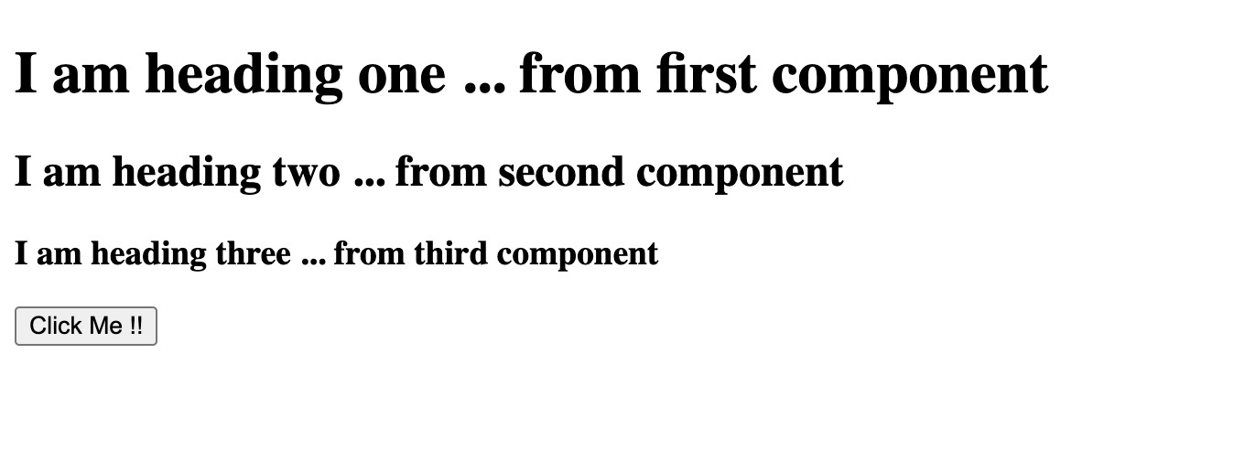

**Challenge 2 => Separate each part of UI in different components :-**

**- We will create 4 components**

1. First will return *'I am heading one ... from first component'*

2. Second component will return *'I am heading two ... from second component'*

3. Third component will return *'I am heading three ... from third component*

4. Fourth component will return *the Button*

Import all this four components in main root function App(){} and UI should be look like below

